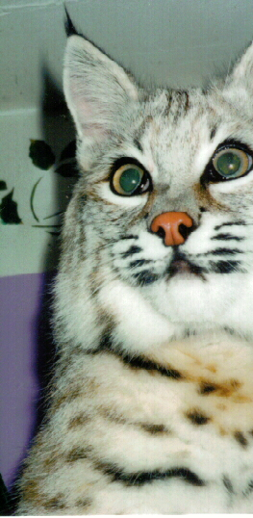 ABOUT THE ARTIST
My name is Bob. I am a Northern Bobcat. I was born at an awful fur farm. My family at MEADOW SWEET FARMS rescued me and my Canadian Lynx buddy from becoming someone’s coat or a stuffed mount on someone’s hearth. Phew!

I love art! I love to paint! I love to create!
My human mom, first noticed my budding talent the time I painted the kitchen in leftover chili, when she wasn’t looking. Chili is a nice medium to work in. It smells so good, I can’t resist rolling in it.
ABOUT THE PAINTINGS:
The paintings are done in non toxic acrylic and water.
Some of the paintings have flecks of basil, oregano and curry added.
I knocked the spices off the counter (when mom wasn’t looking) onto the wet paint, for texture.

I use a special bobcat technique, called jump, drop and roll.
Mom lays out the white paper and puts plates with the non toxic acrylic paint at different places so I can chose my own colors. I have a tin of water so I can wash off my paws or thin the paint. I love to play in water and paint!
The Bobcat technique is very specialized.
I jump in the paint, jump around on the paper then drop and roll, in variations. Each type of roll produces its own affect. Just as human artist use different brushes for different affects I use different rolls or combination of rolls. Because I’m lucky enough to have escaped the fur farm, I wear my own fur, this allows me to be one big paint brush!
all the proceeds from my art work directly to help my animal friends at:
MEADOW SWEET FARMS CENTER FOR THE CONSERVATION AND PRESERVATION OF WILD/ EXOTIC FELINES INC.
PO BOX 251 LOVINGSTON, VA. 22949 (804) 263-6652
EMAIL: MSFWILDCAT@AOL.COM
None of the money goes to humans.
MSF-CCPW/EF Inc. is a private non profit 501-c-3 no kill, rescue shelter for captive raised wild animals that have been displaced or abused.

